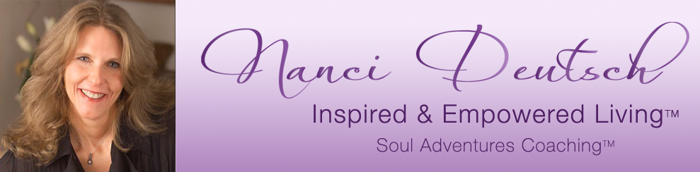

Worksheet for being Grounded, Centered & Present

Journal your experience of the meditation. What do you notice?

Ask Yourself –
What keeps you from being present & grounded? Make a list.

What helps you feel grounded, centered & present? Make a list
(may be same or similar things that bring you peace)

